Lesson 12: Exponential & Logarithmic Applications
Math 2412 Precalculus · Unit 2: Polynomial, Rational, Exponential & Logarithmic Functions · Student Guided Notes
Name: ______________________________ Date: ______________

Lesson objective
Students will use exponential models for compound interest, growth and decay, half-life, Newton's Law of Cooling, and logistic growth, and will solve for unknown times and rates with logarithms.

Before class
Complete these short tasks before the lesson. They review skills this lesson builds on.
- Solve $e^{0.05t}=2$. Give the exact answer and a decimal (Lesson 11).
- Use a calculator to evaluate $1000{(1.06)}^{6}$ and $1000e^{0.36}$.
- Solve $300=70+280e^{5k}$ for k (Lesson 11).

Skill 12.1: Compound Interest

Key ideas
Compounded n times per year: $A=P{(1+\frac{r}{n})}^{nt}$. Compounded continuously: $A=Pe^{rt}$.
Symbol | Meaning
A | ________ (1)
P | ________ (2)
r | ________ (3)
n | ________ (4)
t | the time in years

Example 1: $1000 at 12% for 3 years
Compounded | Calculation | Amount
Annually ($n=1$) | $1000{(1.12)}^{3}$ | $1404.93
Semiannually ($n=2$) | $1000{(1.06)}^{6}$ | ________ (5)
Quarterly ($n=4$) | $1000{(1.03)}^{12}$ | $1425.76
Monthly ($n=12$) | $1000{(1.01)}^{36}$ | ________ (6)
Continuously | $1000e^{0.36}$ | ________ (7)

More frequent compounding earns more, but the amounts level off toward the continuous amount.

Example 2: doubling time
How long does it take money to double at 6% compounded monthly? $2P=P{(1.005)}^{12t}$, so $12t·ln 1.005=ln 2$ and $t=\frac{ln 2}{12ln 1.005}≈11.58$ years.

Practice
a. Find the amount when $5000 is invested at 4.5% compounded quarterly for 10 years. | b. Find the amount when $2500 is invested at 3.8% compounded continuously for 8 years.
c. How long until $3000 grows to $5000 at 5% compounded continuously? | d. What continuous interest rate doubles an investment in 9 years?

Skill 12.2: Exponential Growth & Decay

Key ideas
- Model: $A(t)=A_{0}e^{kt}$, where $A_{0}$ is the ______________ (8) and k is the relative growth rate.
- If $k>0$ the quantity ______________ (9); if $k<0$ it ______________ (10).
- Doubling time: $2=e^{kt}$ gives $t=\frac{ln 2}{k}$. Half-life h: $\frac{1}{2}=e^{kh}$ gives $k=−\frac{ln 2}{h}$.

Example 1: bacteria, $N(t)=90e^{0.05t}$ grams after t days
- Initial amount: $N(0)=90$ grams. Growth rate: 5% per day.
- After 5 days: $N(5)=90e^{0.25}≈115.56$ grams.
- Reaches 140 grams: $e^{0.05t}=\frac{140}{90}$, so $t=20ln(\frac{14}{9})≈8.84$ days.
- Doubles: $t=\frac{ln 2}{0.05}≈13.86$ days.

Example 2: carbon dating
Wood from an archaeological site in Chile has about 1.67% of its original carbon-14. The half-life of carbon-14 is about 5600 years. When was the tree cut?
$k=−\frac{ln 2}{5600}$. Solve $0.0167=e^{kt}$: $t=\frac{ln 0.0167}{k}≈33,062$ years ago.

Practice
a. A town's population is $P(t)=12,000e^{0.023t}$, t years from now. Find the population in 10 years, and when it reaches 20,000. | b. A substance has a half-life of 8 days. How much of a 50 mg sample is left after 20 days? | c. A bacteria culture triples in 4 hours. Find the growth rate k.

Skill 12.3: Newton's Law of Cooling

Key ideas
Newton's Law of Cooling: $u(t)=T+(u_{0}−T)e^{kt}$, where T is the temperature of the surroundings, $u_{0}$ is the starting temperature of the object, and k is a ______________ (11) constant.
- As t grows, $e^{kt}→0$, so $u(t)$ approaches ______________ (12), the room temperature.
- Usually one measurement is used to find k, then the model answers the question.

Example: a cake
A cake at 350°F cools in a 70°F room. After 5 minutes it is 300°F.
- Model: $u(t)=70+280e^{kt}$. Find k: $300=70+280e^{5k}$, so $e^{5k}=\frac{23}{28}$ and $k=\frac{ln(\frac{23}{28})}{5}≈−0.0393$.
- When is it 200°F? $280e^{kt}=130$, so $t=\frac{ln(\frac{13}{28})}{k}≈19.5$ minutes.
- When is it 100°F? $280e^{kt}=30$, so $t=\frac{ln(\frac{3}{28})}{k}≈56.8$ minutes.
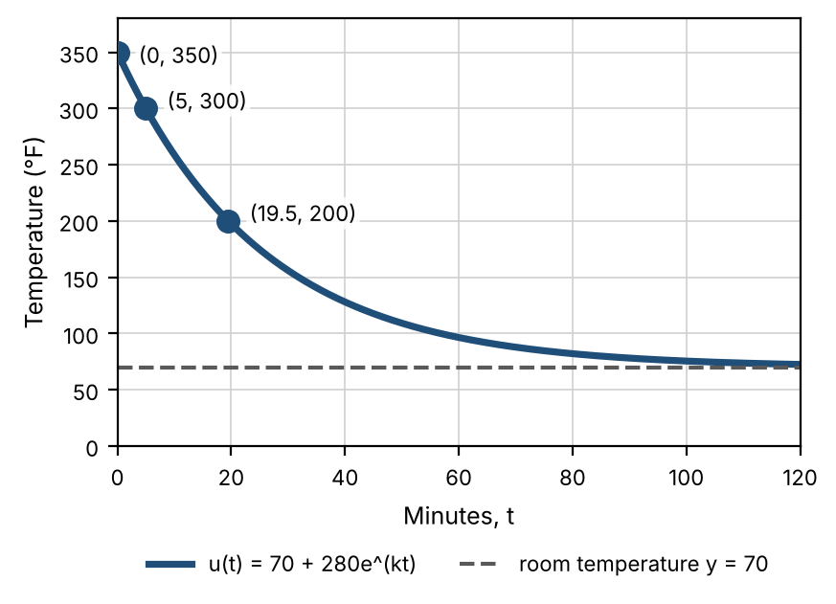

Practice
a. Coffee at 190°F is left in a 72°F room. After 10 minutes it is 150°F. When will it be 120°F? | b. Will the cake in the example ever cool to 60°F? Explain using the model.

Skill 12.4: Logistic Growth

Key ideas
Logistic model: $f(t)=\frac{c}{1+ae^{−bt}}$, where c is the ______________ (13) (the upper limit), $\frac{c}{1+a}$ is the initial value, and b is a positive growth constant.
- Growth is nearly exponential at first, then slows as the population nears c.
- The graph is an S-shaped curve with horizontal asymptotes $y=0$ and $y=c$.

Example: the flu in a community of 1000 people
One person has the flu at $t=0$. At most 1000 people can catch it, and $b=0.6030$.
- Find a: $\frac{1000}{1+a}=1$, so $a=999$. Model: $f(t)=\frac{1000}{1+999e^{−0.603t}}$.
- After 10 days: $f(10)=\frac{1000}{1+999e^{−6.03}}≈294$ people.
- 75% (750 people): $1+999e^{−0.603t}=\frac{4}{3}$, so $e^{−0.603t}=\frac{1}{2997}$ and $t=\frac{ln 2997}{0.603}≈13.3$ days.
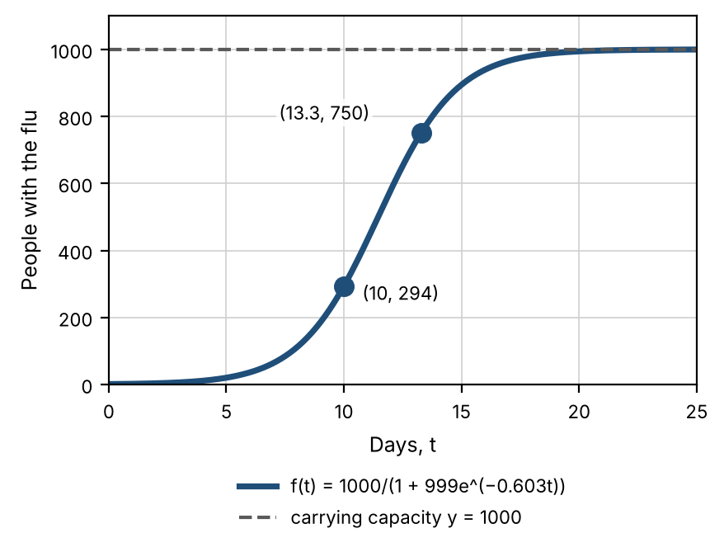

Practice
a. A lake is stocked with 400 fish. The lake can support at most 2400 fish, and $b=0.35$ per year. Write a logistic model, find the population after 5 years, and find when it reaches 2000.

Exit check
1. Find the amount when $2000 is invested at 5% compounded monthly for 4 years.

2. A substance has a half-life of 10 years. What percent is left after 25 years?

3. For $P(t)=\frac{500}{1+24e^{−0.4t}}$, find the carrying capacity and the initial population.

